Assignment 2

SQL – ‘World’

Task 1 & 2

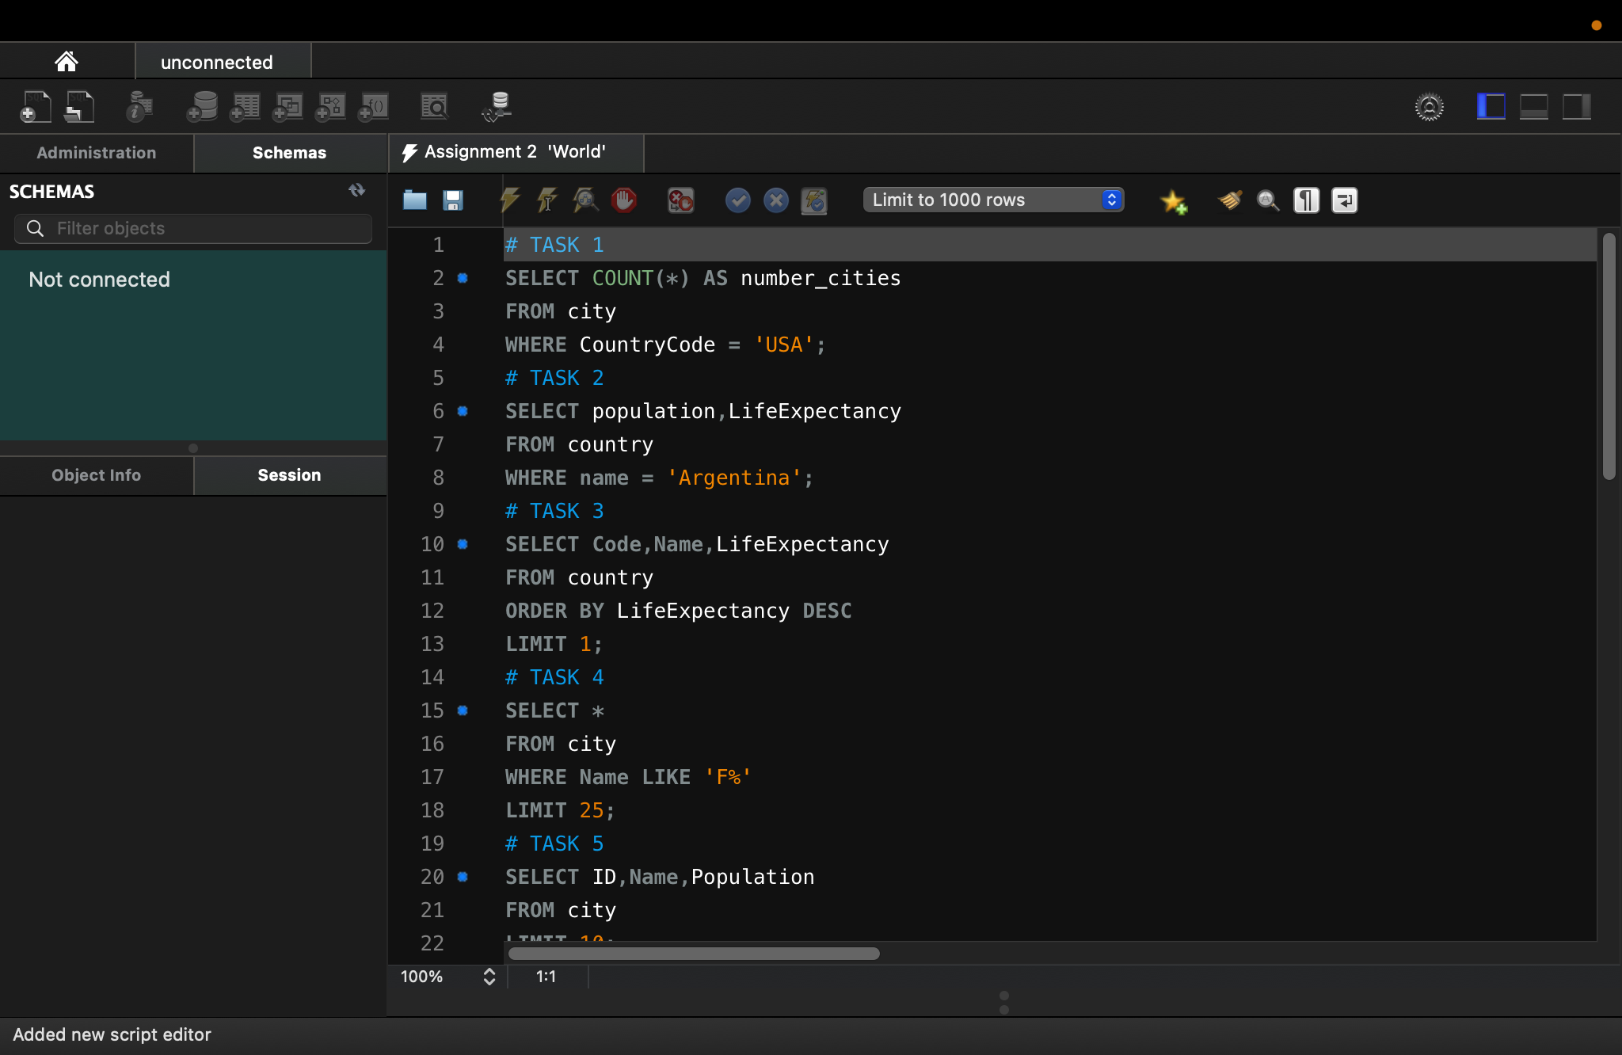

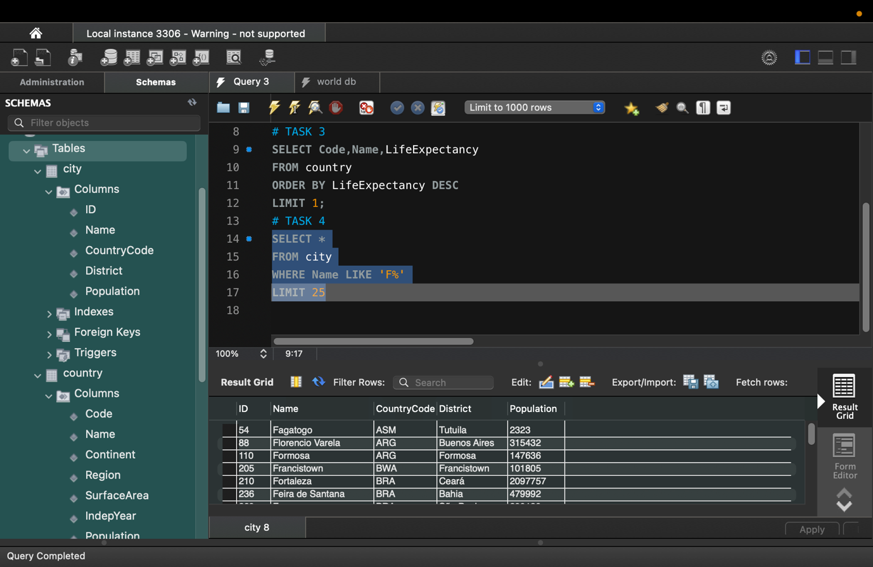Task 3 & 4

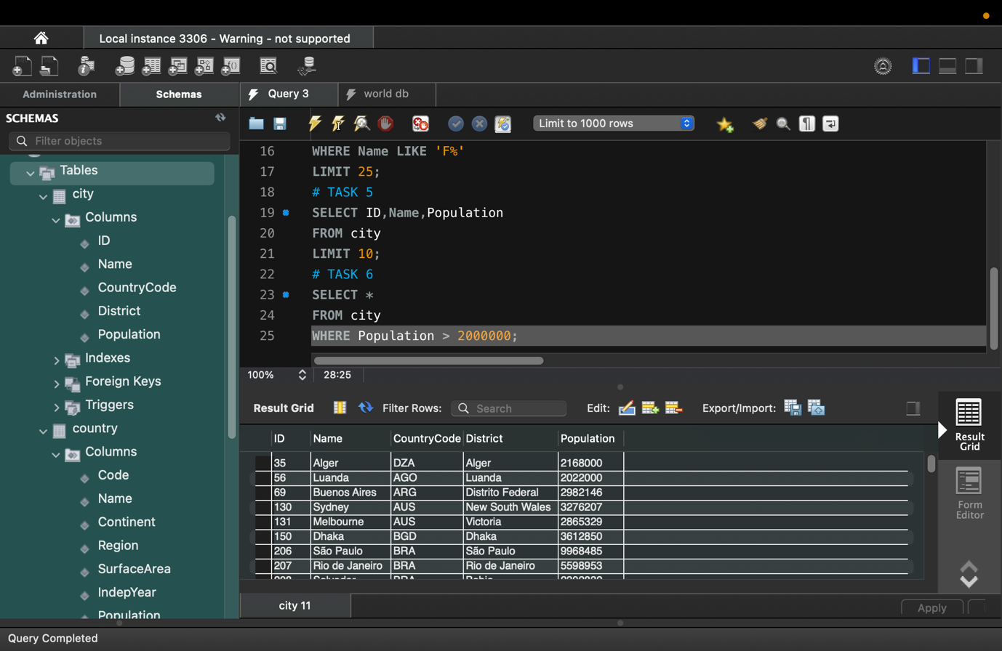Task 5 & 6

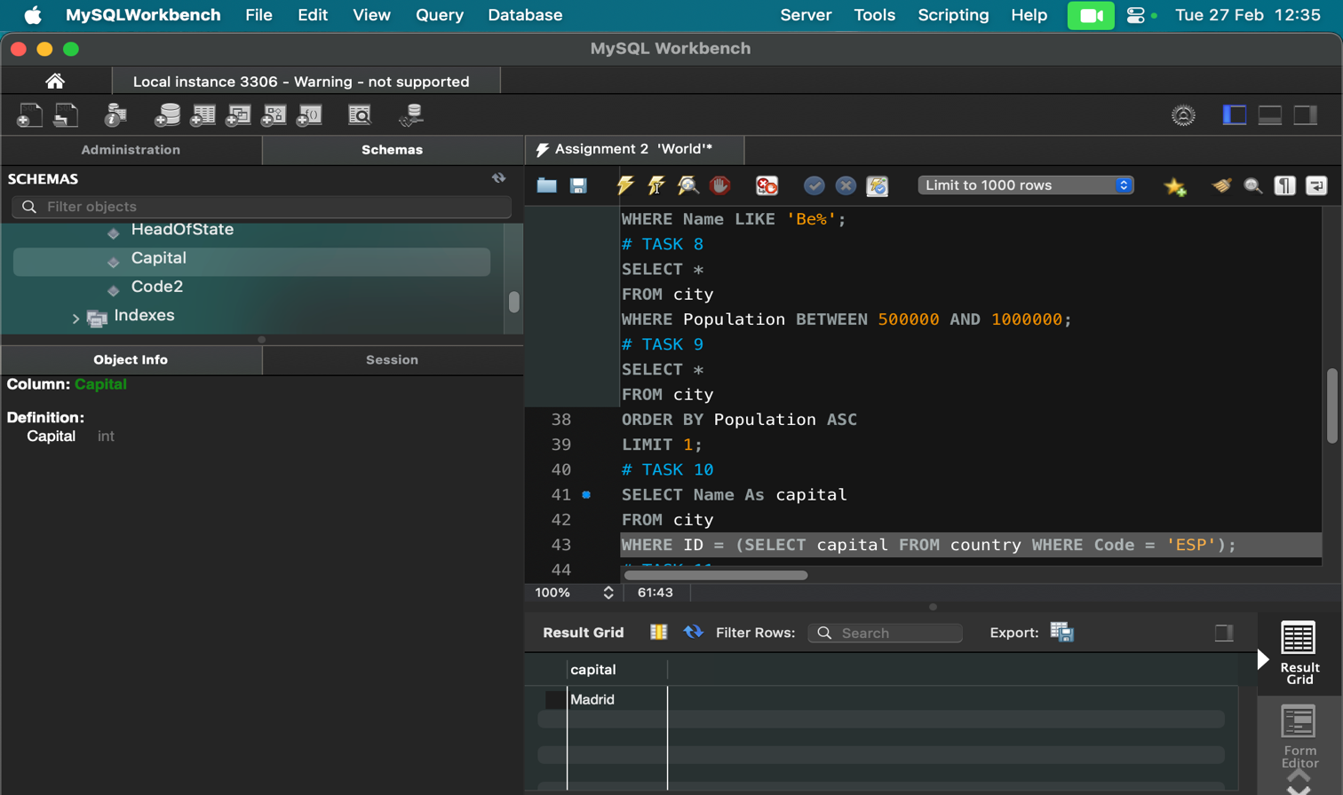Task 8, 9 & 10

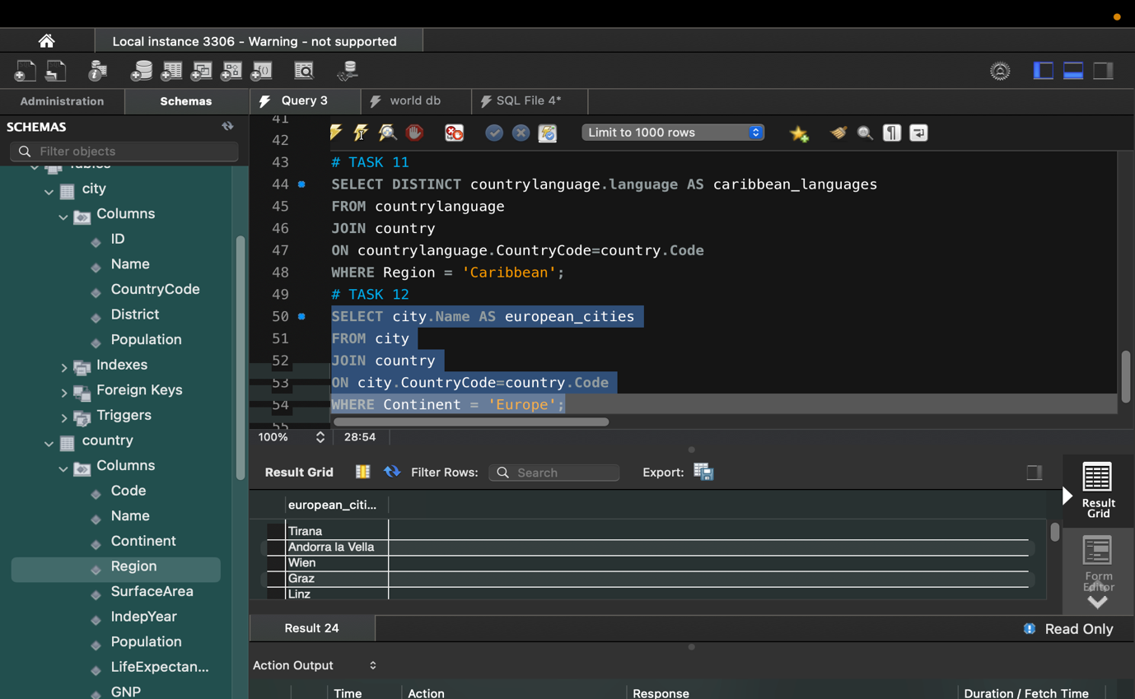Task 11 & 12

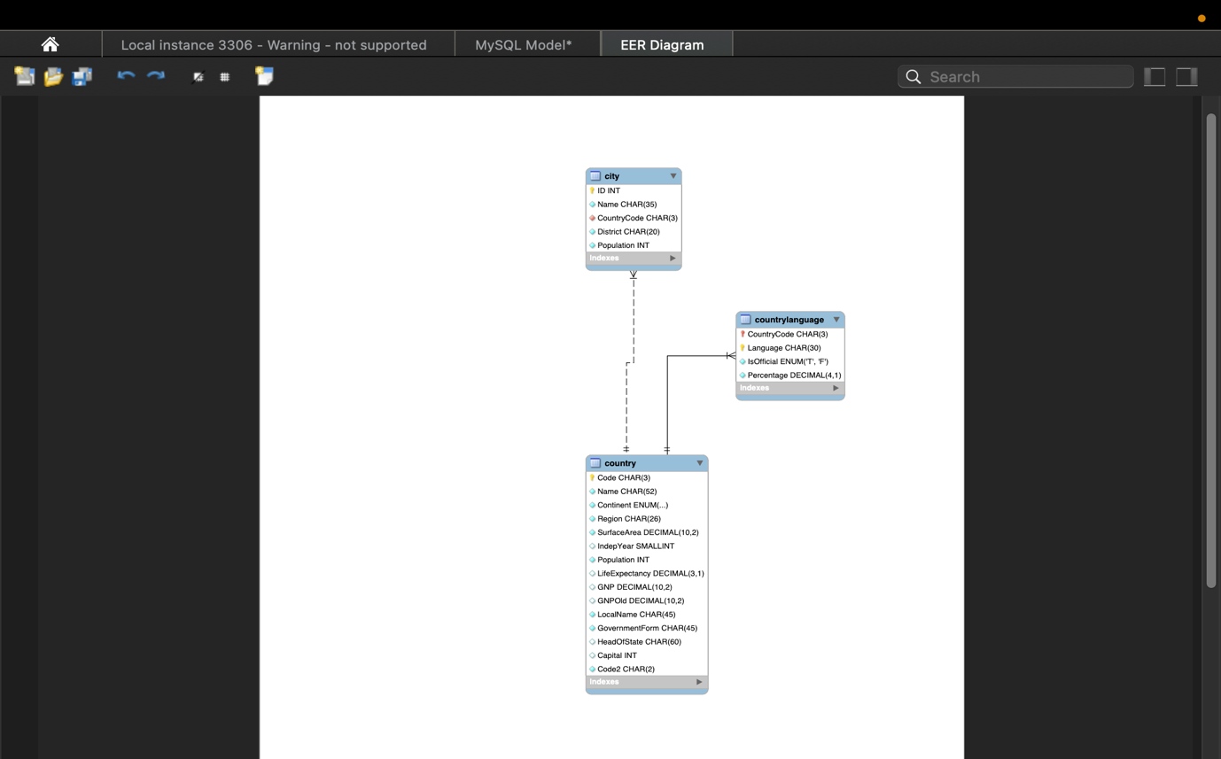Task 13

* country - primary key - Code;
* city - primary key - ID; foreign key - CountryCode;
* countrylanguage - primary key - Language; foreign key - CountryCode.